Assignment of
Advanced Object-oriented Technology

User Documentation
Module Code: | ITD 3431
Module Name: | Advanced Object-oriented Technology
Course Code: | 41303
Course Title: | Software Engineering
Student ID.: | 070323135
Year: | 3
Group: | A

Table of Content

Cover Page | P. 1
Table of Content | P. 2
Available command | P. 3
Main Screen | P. 4
Command – e | P. 5
Command – cl | P. 6 – P. 11
Command – dl | P. 12
Command – ch | P. 13 – P. 14
Command – sl | P. 15
Command – ud | P. 16 – P. 17
Command – rd | P. 18 – P. 19
Test Cases 1 | P. 20 – P. 24
Test Cases 2 | P. 25 – P. 27
Test Cases 3 | P. 28 – P. 32

Available command

Command | Usage
e | Exit the current system
cl | Create a new license
ch | Change an existing license
dl | Display all existing licenses
ud | Undo the previous step
rd | Redo the latest undone step
sl | Show lists of all undo step and redo step

Main Screen

Run cmd.exe, go into folder “Java code”, input “java mainPack.DizzylandLMS” then press[Enter]

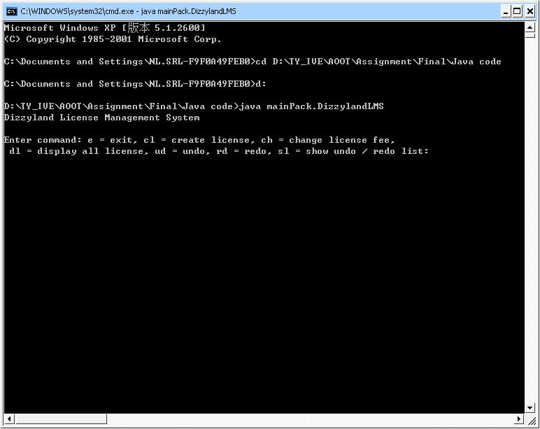

Command – e

In the Main Screen, press “e” then press [Enter], system will exit with exit code 1 (that means no error).

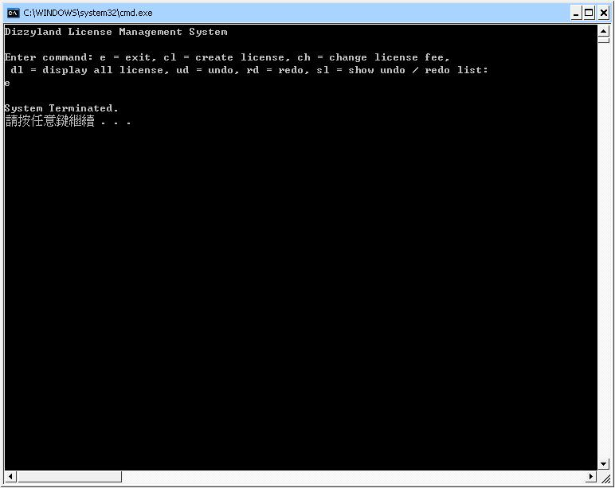

Command - cl

In the main screen, input “cl” then press [Enter] to getting in the create license mode:

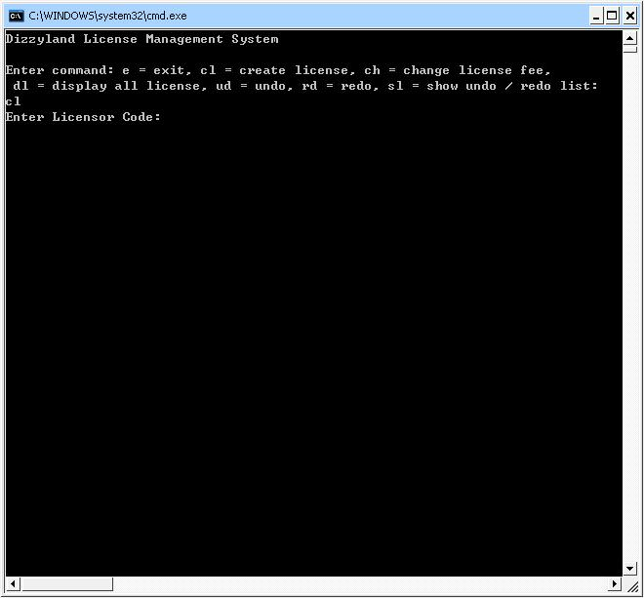

Command - cl

Then input the licensor code, for example, mc (Marcel Entertainment):

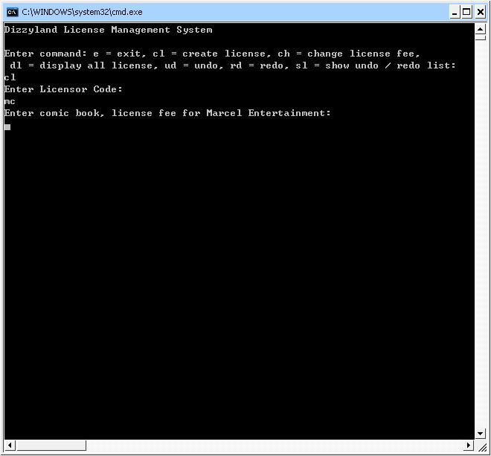

Command - cl

After that, input requested license properties, each property must separate by “, ”

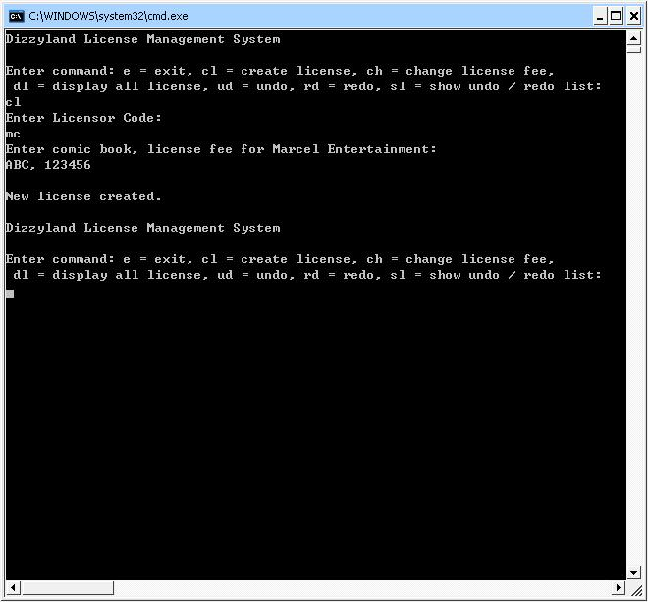

Command - cl

Other example of command - cl:

Command - cl

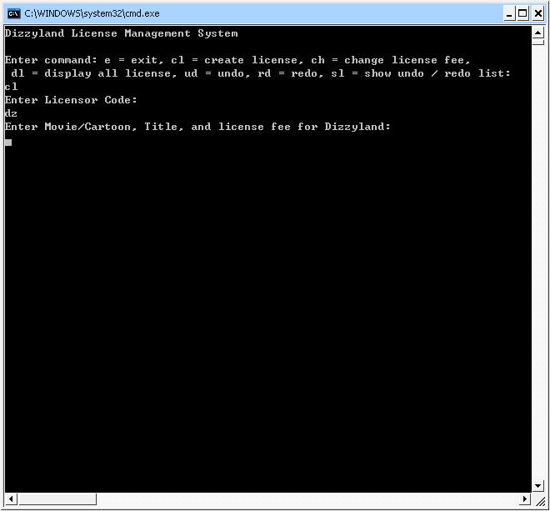

Command - cl

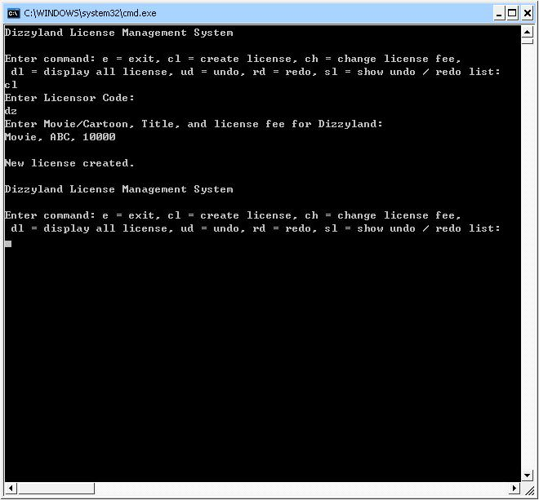

Command - dl

In the main screen, key in “dl” then press [Enter] can display all existing licenses:

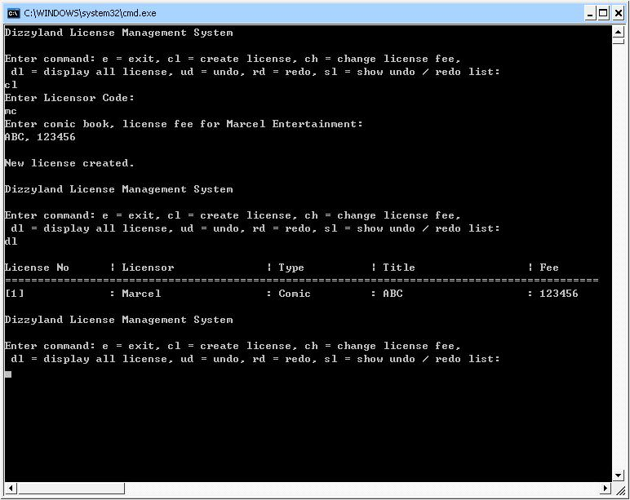

Command - ch

After created a license, input “ch” in the main screen then press [Enter] will go into change license fee mode:

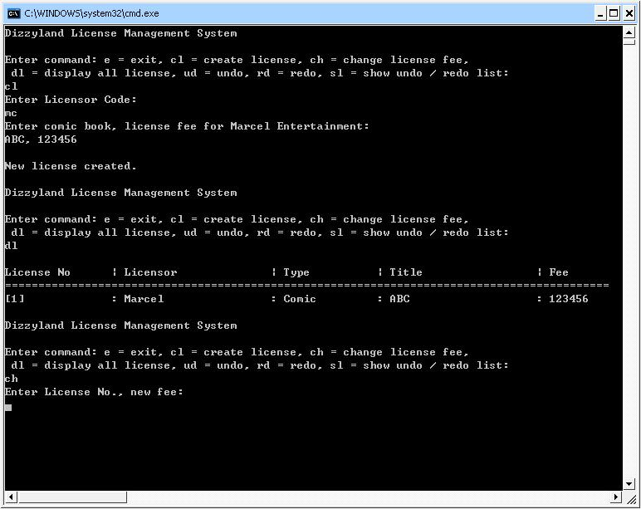

Command - ch

In change license fee mode, input license No. and new fee then press [Enter] to make change, license No. and new fee must separate by “, ”:

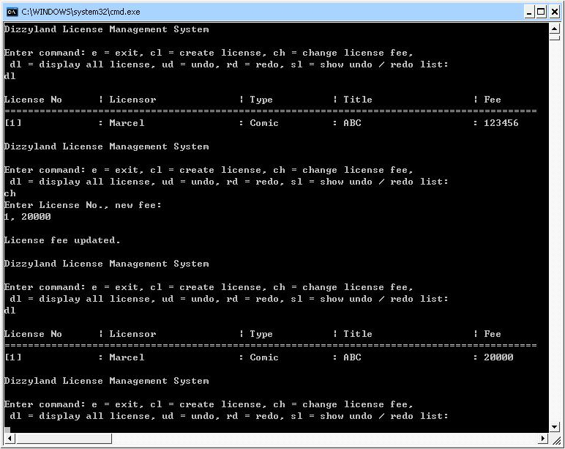

Command - sl

Input “sl” then press [Enter] in the main screen can show lists of undo list and redo list

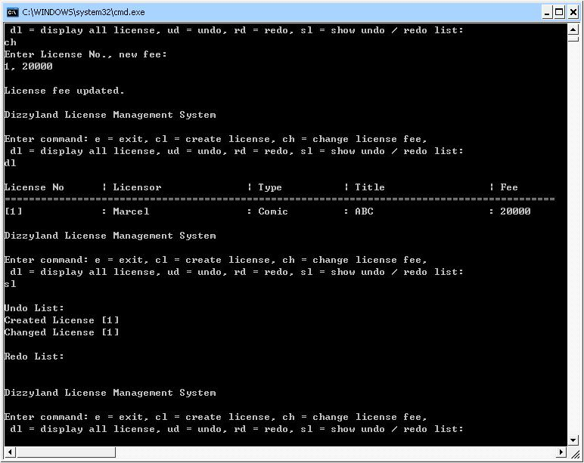

Command - ud

Input “ud” in the main screen then press [Enter] can undo the previous step:

Command - ud

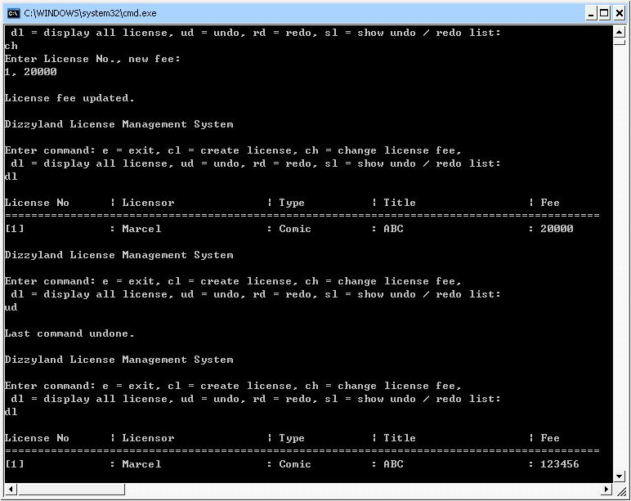

Command - rd

Input “rd” in the main screen can redo the undone command

Command - rd

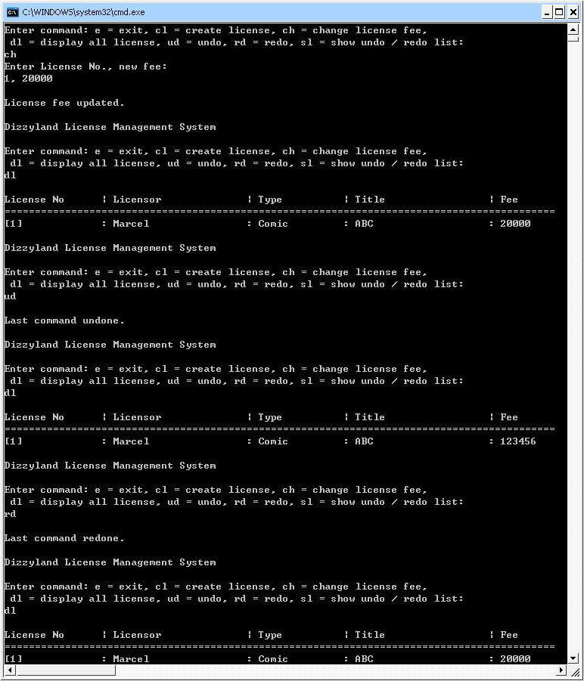

Test Cases 1

There is two licenses are going to create:
License 1 –
Licensor: Dizzyland
Type: Cartoon
Title: Batman
Fee: 10000
License 2 –
Licensor: Marcel Entertainment
Type: Comic
Title: Matrix
Fee: 50000

After licenses are created, license’s fee of License 2 is told as wrong, it should be 30000.

Test Cases 1 –
Screenshot

Create License 1:

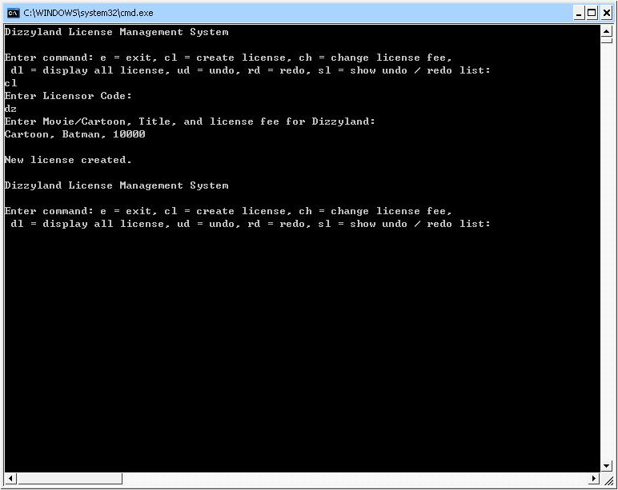

Test Cases 1 –
Screenshot

Create License 2:

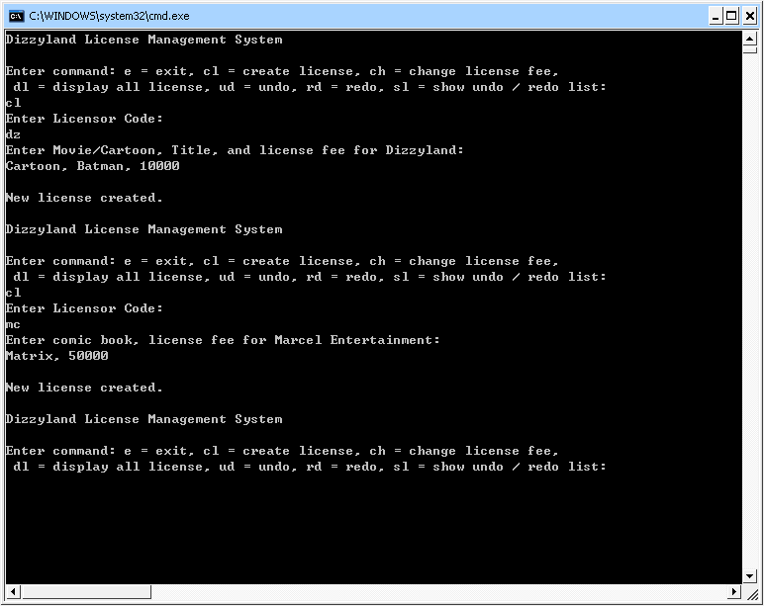

Test Cases 1 –
Screenshot

Display licenses

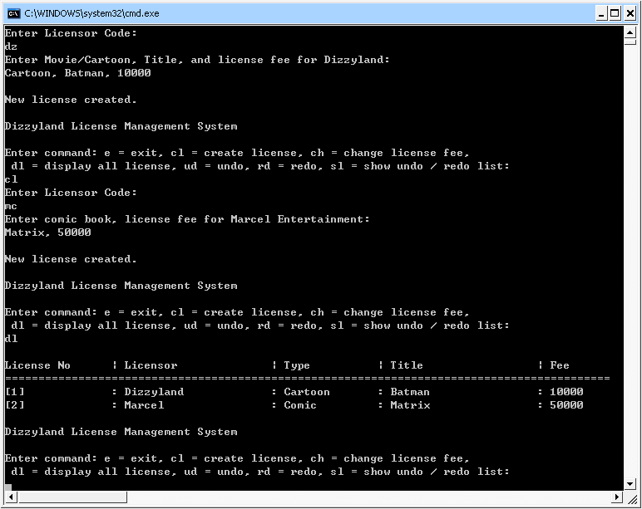

Test Cases 1 –
Screenshot

Change fee of License 2 from 50000 to 10000

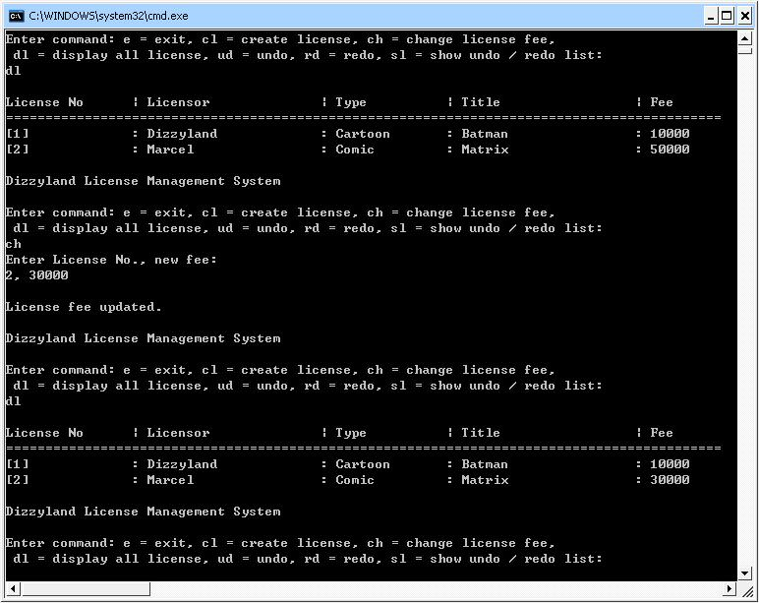

Test Cases 2

There are two licenses:
License 1 –
Licensor: Dizzyland
Type: Cartoon
Title: Batman
Fee: 10000
License 2 –
Licensor: Marcel Entertainment
Type: Comic
Title: Matrix
Fee: 30000

Fee of license 2 is just changed from 50000 to 30000.

After a while, license 2 is confirmed with fee 50000, just undo the previous step (change license fee).

Licensor is now saying the license 2 does no longer need, undo the step that create license 2.

Test Cases 2 –
Screenshot

Undo the change license fee step:

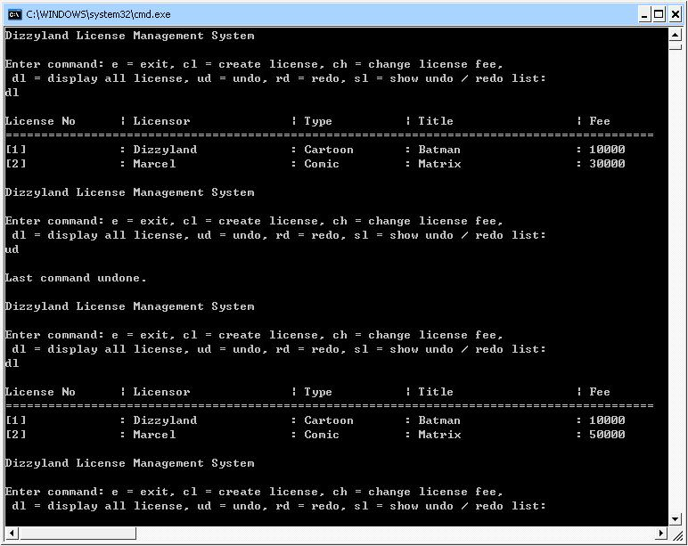

Test Cases 2 –
Screenshot

Undo the create license 2 step:
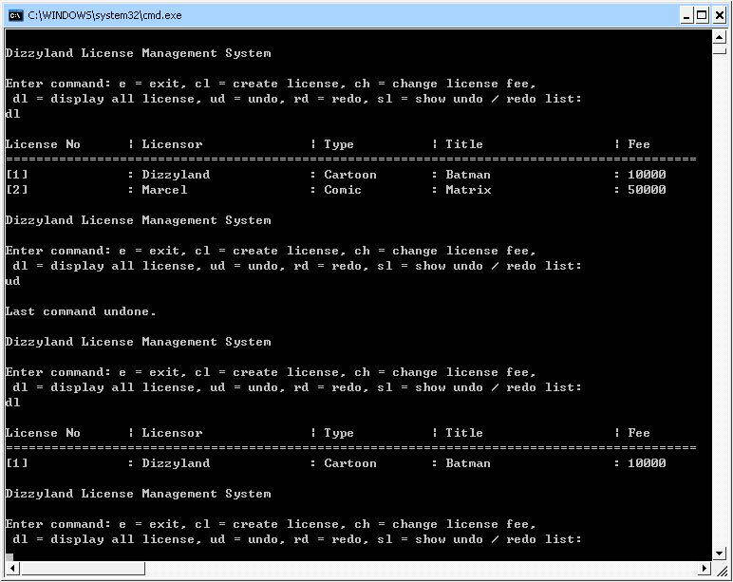

Test Cases 3

Follow by test cases 2, now there is a report request to show every step of test cases 2.

Besides that, redo all steps and give a print screen.

Also, show every step after redo all steps.

Test Cases 3 –
Screenshot

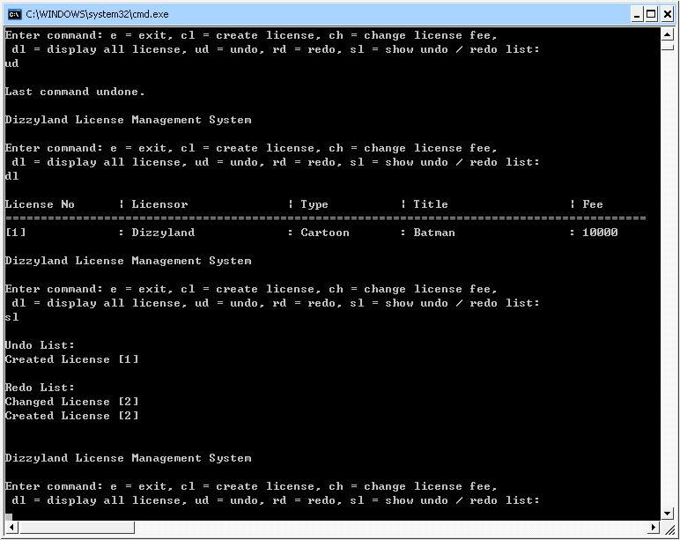

Test Cases 3 –
Screenshot

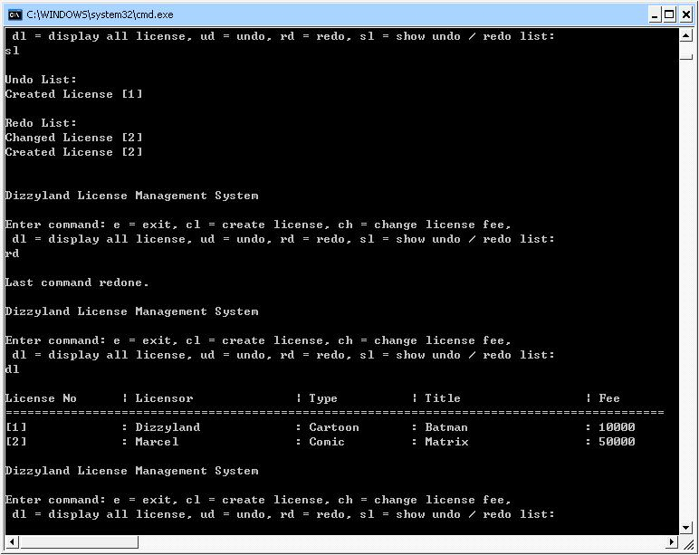

Test Cases 3 –
Screenshot

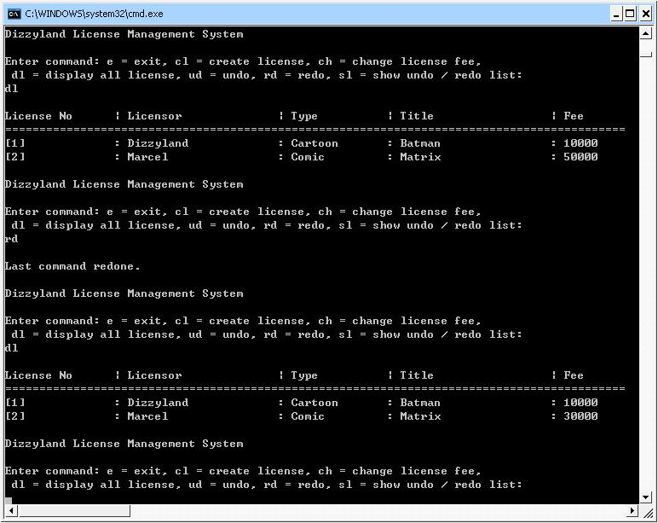

Test Cases 3 –
Screenshot

